**geerdCh 3 Homework Instructions**

**Part A: Normalization**

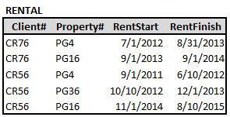Consider the following tables:

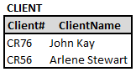

1. b)

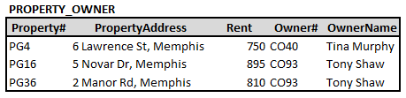

c)

1. List the functional dependencies found in each table above.
2. Client

(CR76) (John Kay)

(CR76, PG4) (7/1/2012 8/31/2013)

(CR76, PG16) (9/1/2013, 6/12014)

(CR56, PG4) (9/1/2011, 6/10/2012)

(CR56, PG36) (10/10/2012, 12/1/2013)

(CR56, PG16) (11/1/2014, 8/10/2015)

1. In each above put them in sentence structure:

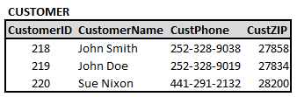

Example:

Sentence Structure:

CUSTOMER (CustomerID, CustomerName, CustPhone, CustZIP)

1. c

CUSTOMER (281, John Smith, 252-328-9038, 27858)

CUSTOMER (219, Doe John, 252-328-9019, 27834)

CUSTOMER (220, Sue Nixon, 441-291-2132, 28200)

1. Do each of the tables in 2) above, violate 1st Normal Form? If so, correct them in Sentence Structure, if not copy them from 2) above.
2. Yes or( No) (Circle)

CUSTOMER (281, Smith John 252-328-9038, 27858)

1. Yes or ( No) (Circle)

CUSTOMER (219, Doe John, 252-328-9019, 27834)

1. Yes or No (Circle)

CUSTOMER (220, Nixon Sue, 441-291-2132, 28200)

1. Do each of the tables in 3) above, violate 2nd Normal Form? If so, correct them in Sentence Structure, if not copy them from 3) above.
2. Yes or ( No ) (Circle)

CUSTOMER (281, John Smith, 252-328-9038, 27858)

1. Yes or (No) (Circle)

CUSTOMER (219, Doe John, 252-328-9019, 27834)

1. Yes or (No ) (Circle)

CUSTOMER (220, Sue, Nixon, 441-291-2132, 28200)

1. Do each of the tables in 4) above violate 3rd Normal Form? If so, correct them in Sentence Structure, if not copy them from 4) above.
2. Yes

CUSTOMER (281, John Smith, 27858)

CustPhone (John Smith, 252-328-9038)

1. Yes

CUSTOMER (219, Doe John, 252-328-9019, 27834)

CustPhone (Doe John, 252-328-9019)

1. Yes

CUSTOMER (220, Nixon Sue, 28200)

CustPhone (Nixon Sue, 441-291-2132)

**Part B: Normal Form Violations**

(When normalizing the tables/fields, be sure to identify the primary key(s) by underlining and the foreign keys by italics)

1. **ECU keeps a transcript for all students**

TRANSCRIPT (TransClassID, TransStudentID, TransGrade, TransInstructorID, TransRoomID, TransRoomCapacity)

**Normal Form Violated: 1NF**

**Why? BECAUSE YOU**

Non attribute TransRoomID determine TransRoomCapacity

**Corrected to**

TRANSCRIPT (TransID, SrudentID, ClassID, TransGrade)

STUDENTS (StudentID, studentName)

INSTRUCTOR (InstructorID, InstructorName, InstructorClasssID)

ROOM (RoomID, RoomCapacityID)

1. **Professors keep a list of the students they coach in the COB Leadership program.**

COACHEE (CoachProfessorID, CoachStudentID, CoachStartDate, CoachEndDate, CoachStudentName)

**Normal Form Violated: 1NF**

**Why?**

**Corrected to 3NF:**

CAOCHED (ProfessorID, StudentsID, CoachStartDate, CoachEndDate)

STUDENT (StudentID, StudentName)

COACHED (ProfessorID, StudentID, CoachStartDate, CoachEndDate)

PPROFESSOR (ProfessorID, ProfessorName)

**Part C: Covert a form into Tables**

**Convert the form below into tables and fields putting them into 3rd Normal Form. Use a Sentence Structure.** Note: It may be useful to determine the tables (themes) first and then determine the fields. One way to begin is to circle fields and label them as to which table they refer to! Be sure to

Underline Primary Keys and show *Foreign Keys* in italics! Add any needed surrogate keys!

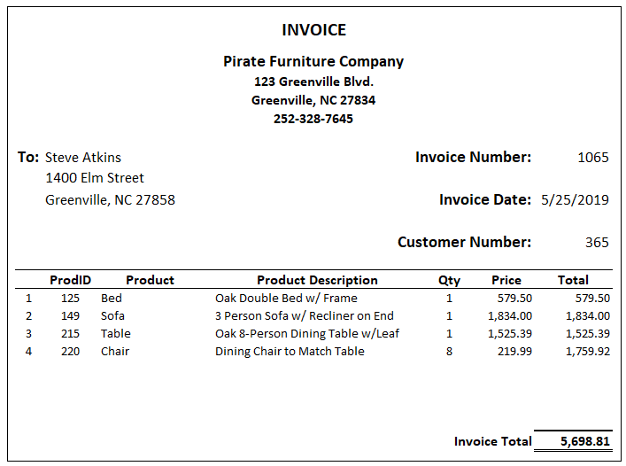Solution is on the next page!

**Solution**

COMPANY (CoID, CoName, CoAddress, CoState, CoZip)

PRODUCT (ProdID, Item Price)

CUSTOMER (CustID, CustName, CustAddress, CustCity, CustState, CustZIP)

INVOICE (Invoiced, CustID, InvoiceDate, TotalInvoice)

PRODUCT LINE (ProducID, ProductName, Pruct#, Proctprice)